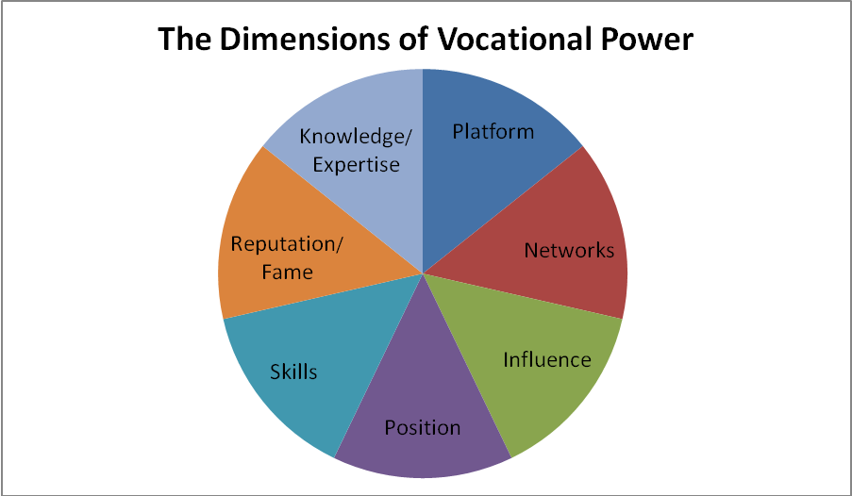

Knowledge: specific knowledge gleaned from formal education or on-the-job experience in a particular field; it is important for congregants to consider how such specialized knowledge may be transferable to other contexts outside their firm
Platform: having a voice, an opportunity to get out a message
Networks: professional contacts (e.g., co-workers, fellow alumni, vendors, suppliers, customers, regulators, business partners); one’s network is usually broader than one realizes!
Influence: capacity of causing an effect in indirect or intangible ways (here it is important help congregants realize they may have more influence than they think, for influence is not synonymous with position/seniority)
Position: seniority, level of authority, decision-making power within an organization. Also the organization itself may have positional power (NY Times has more positional power than local newspaper)
Skills: Live Your Calling by authors Kevin and Kay Marie Brennfleck identifies and categorizes 62 specific skills. Congregants usually possess more than they realize at first glance. As with knowledge, it is good to get them thinking about the transferability of their skills; how the same skills they apply at work can be applied in other contexts.
Reputation/Fame: may afford entrée to powerbrokers, capacity for mobilizing a large following, or strategic opportunities to direct wide scale attention to a particular issue or cause

